**Current S&P 500 PE Ratio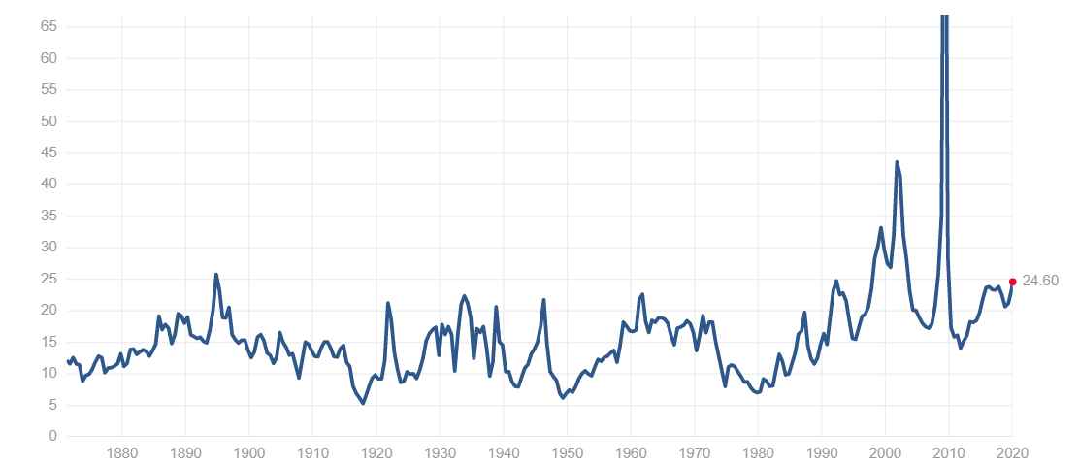Current Shiller PE Ratio**

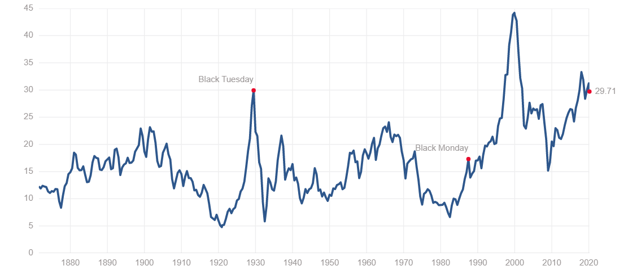

Source: <https://www.multpl.com/s-p-500-pe-ratio>

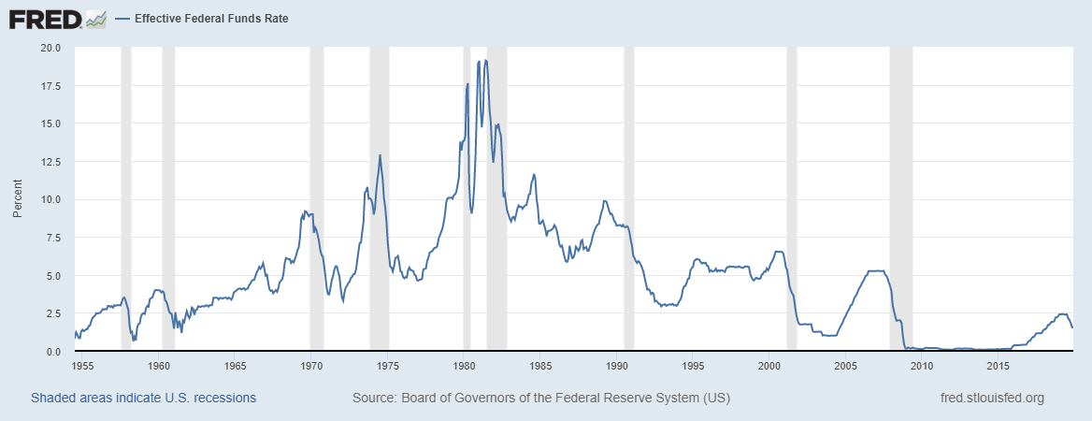

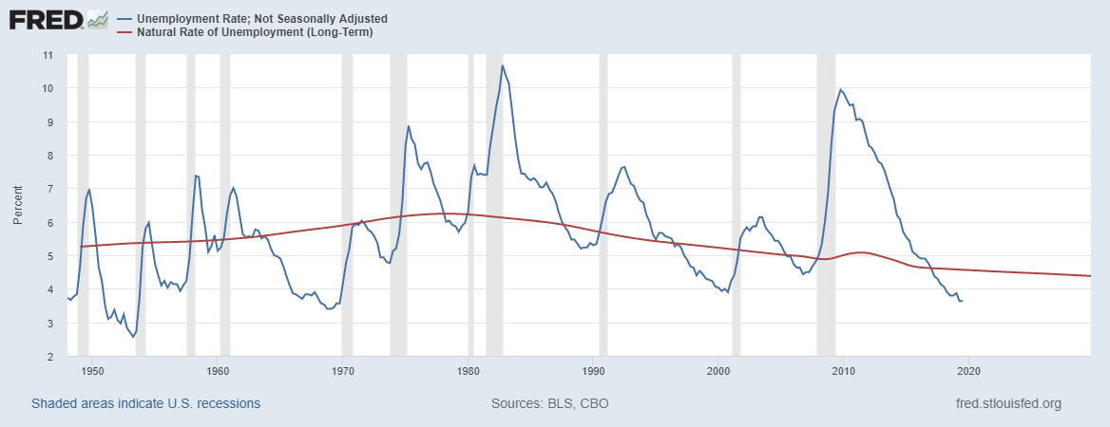

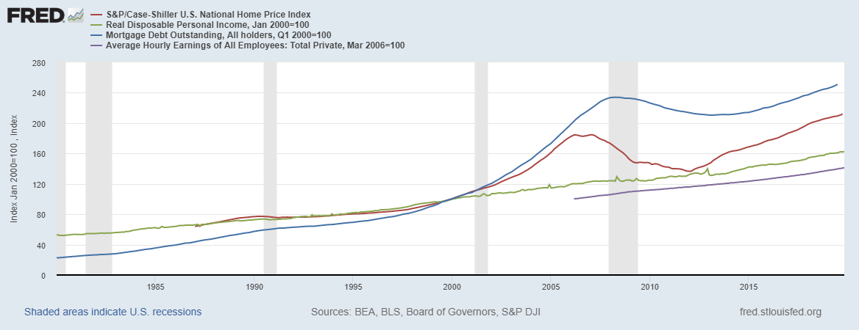

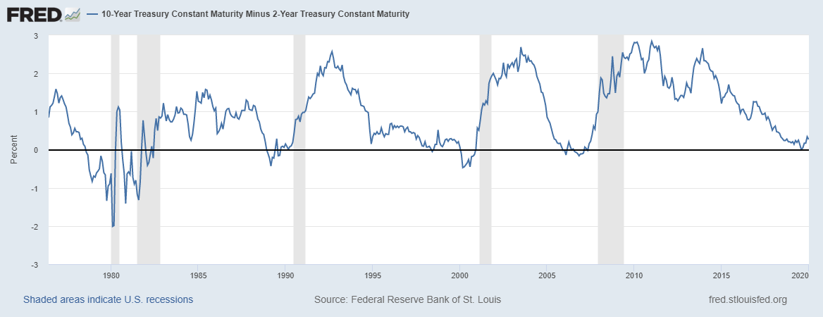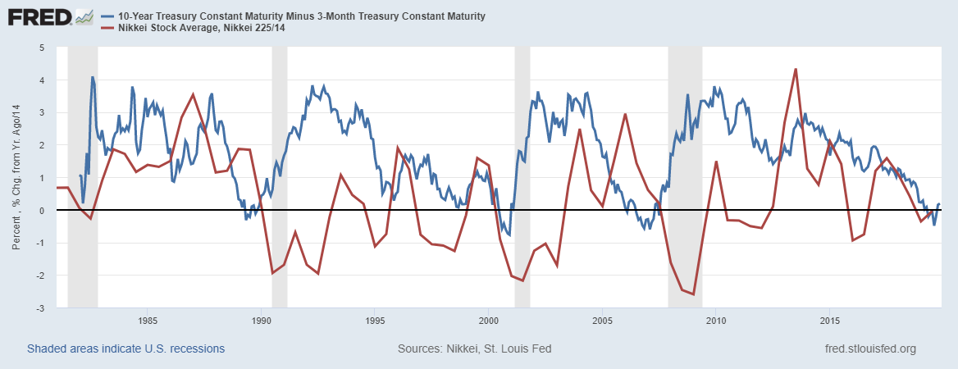

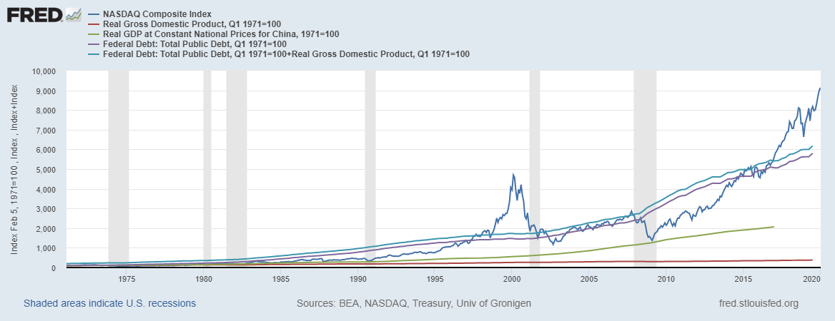

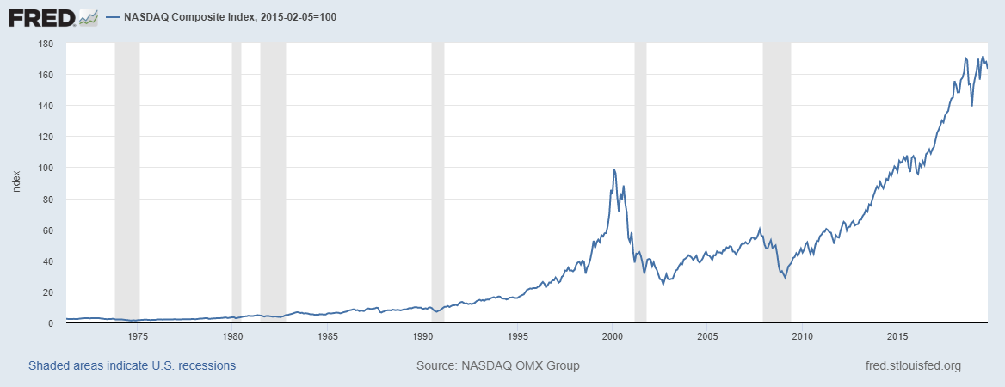

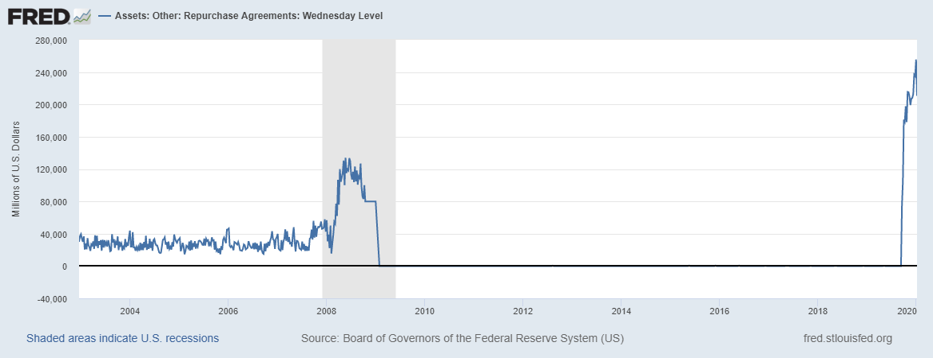

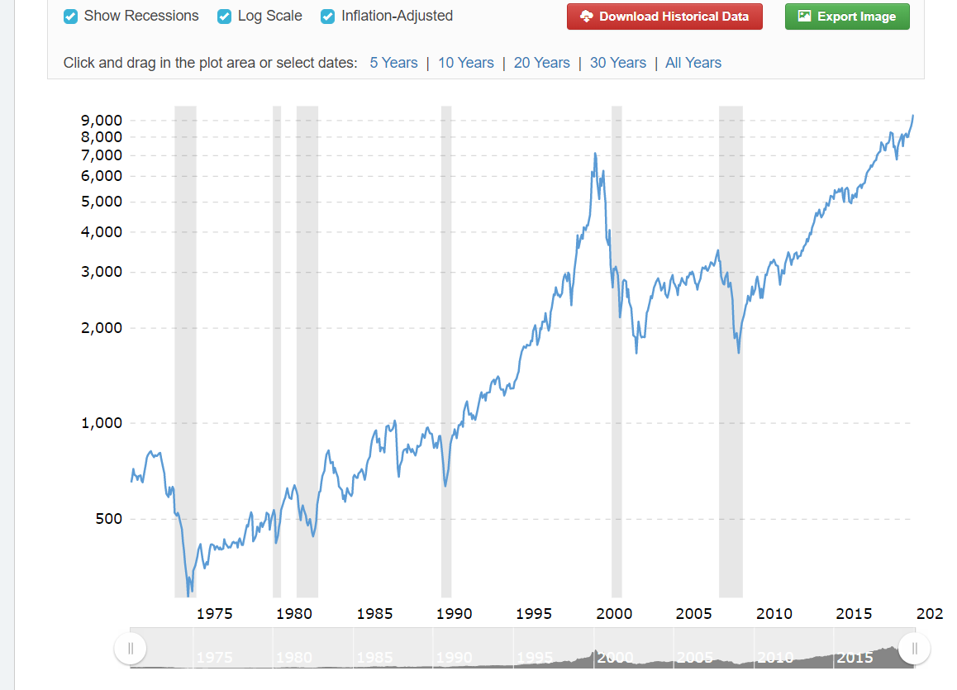log scale graph of inflation adjusted nasdaq

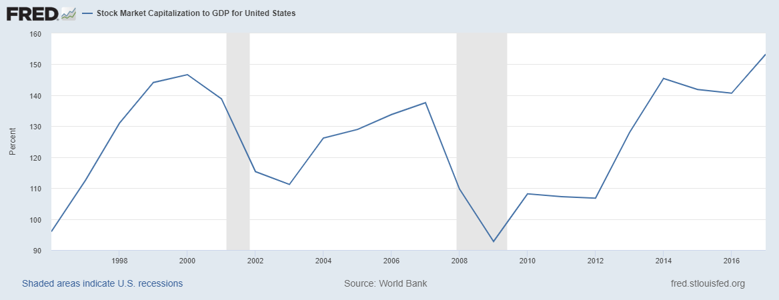

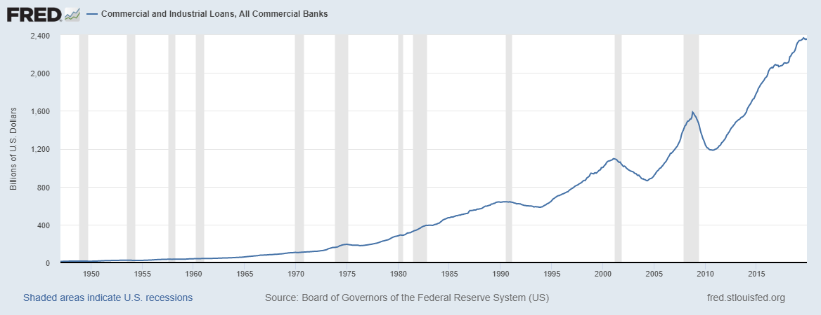

Same as above but with February numbers baked in… maybe I should do this with all graphs to visualize the change and analyze prediction accuracy and results.

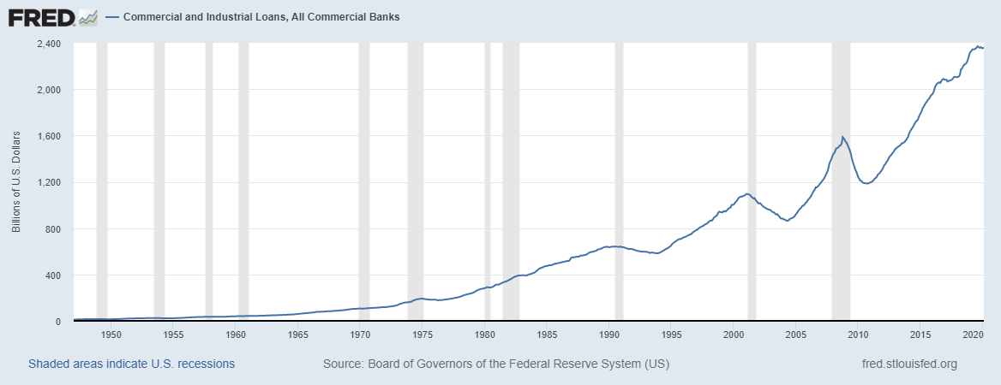

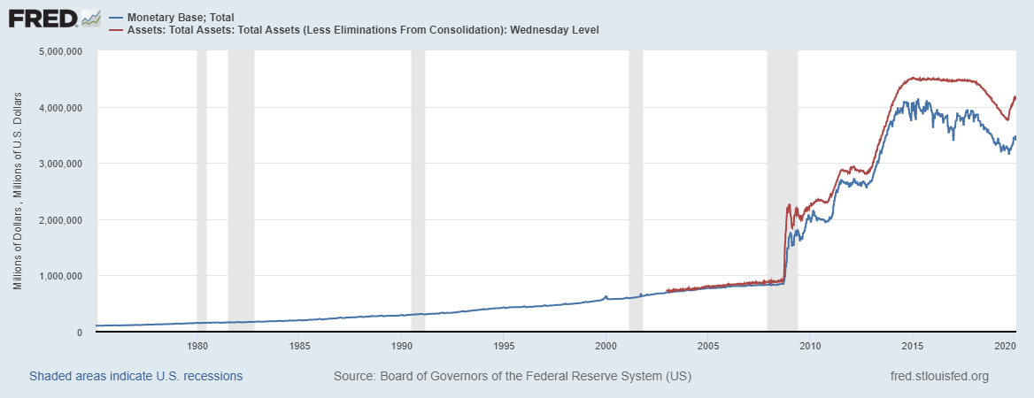

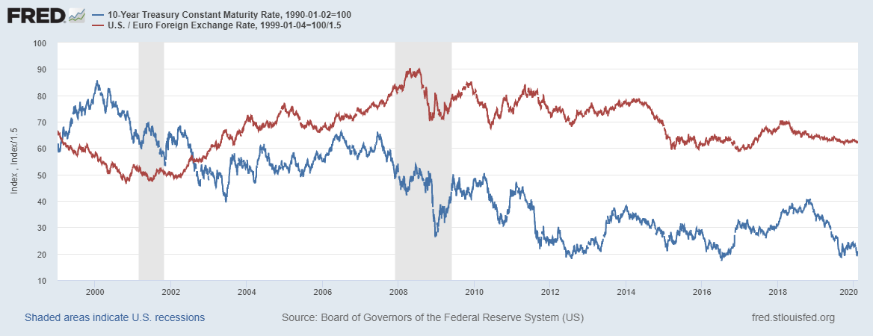

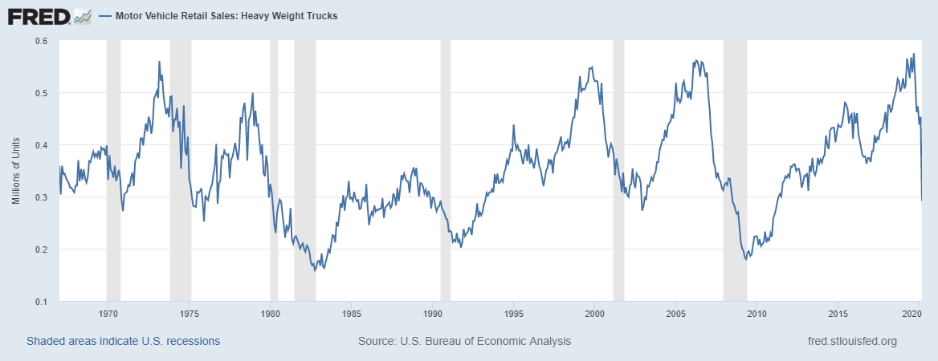

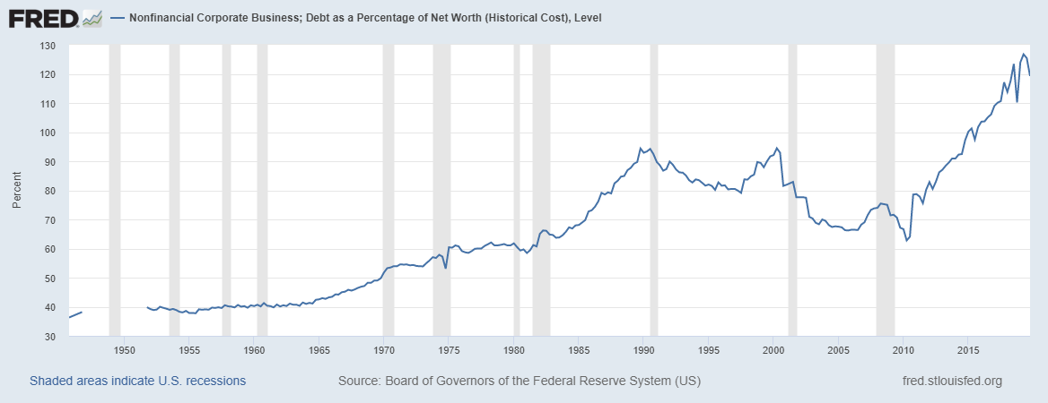



Strategy:

1. Be long on naked puts
2. Once the stock market begins free falling, slowly sell options and begin purchasing equities with weekly DCA strategy
3. Focus on the nasdaq...it historically outperforms the s&p 500
4. Once there is public agreement of a recession and GDP is announced to have fallen, switching completely into equities.
5. Try to borrow as much money as possible at as little interest as possible to purchase max equities
6. Wait until capital gains are taxed as long term capital gains before pulling out any money
7. Months after the recession is officially announced, purchase rental properties since the real estate market has a 6 month lag of the stock market
8. As prices recover in the real estate market fall, consider cash out refinances as interest rates fall (because the Fed wants to stimulate spending).
9. BRRR